Dear New Association,
Embarking on your inaugural year of participation in the Gay World Series may present various challenges. We aim to ensure that your association comprehends all available options concerning the inclusion of your first team or teams in the GSWS. Should any inquiries arise, please know that we are here to provide assistance. Our goal is to facilitate your city's seamless integration during your initial membership year.

Best Regards, Jon Brenes Membership Chair
Email: membershipchair@ipridesoftball.org

FAQ: How Many Teams Can I Send to the GSWS?
The allocation of your association's berths is contingent upon the number of registered regular season teams. However, we expect each association to send at least one team per GSWS event. It's crucial to ensure your players meet eligibility and division requirements and that your team does not exceed three non-LGBTQIA+ players.
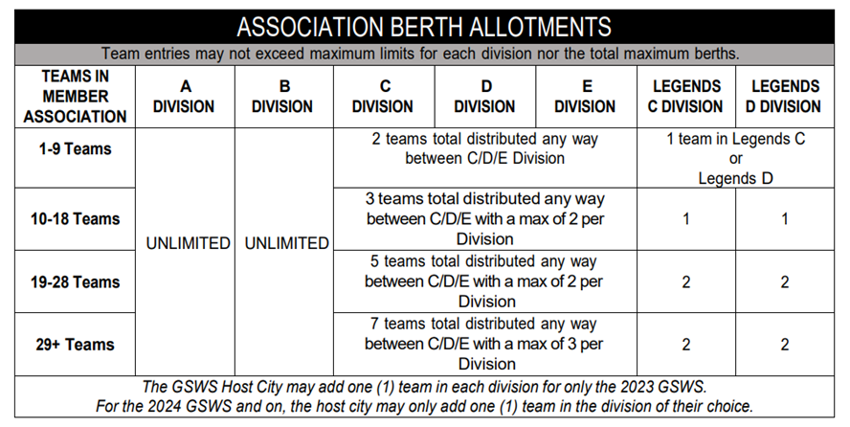
Sending 1 Team as an Organization:
Opting to send one team to the GSWS represents the simplest approach in your inaugural year. Here are your alternatives:
- Sending a Standard Roster Team: Designate an official league team to represent your organization. This team can be selected via a qualifying event (such as a season or tournament winner) or by volunteers from within your association. The roster should comprise a minimum of ten (10) players and a maximum of 20. Establish clear local qualification guidelines before the season commences. Additionally, the Standard Roster team can augment its roster by selecting up to four players from other teams, provided they meet minimum regular season and division requirements and are regular season players for the organization.
- Sending an All-Association Roster: This option involves submitting a GSWS roster comprising players solely from regular season rosters of multiple teams within your association. However, only one team can be sent to the GSWS for the division using this method.
- Sending an Extended Association Roster: If your organization is sending only one team, you're permitted to select up to four players from other associations to complete your team’s submission.
- Sending a Legends Division Roster: For those considering sending a Legends Team (comprising players over 50), there's flexibility to pick an unlimited number of players from your organization and other organizations.

Sending More Than 1 Team for the Association:
Approaches differ when sending multiple teams:
- 2 Teams in the Same Division: In this case, only Standard Roster teams are permissible. Ensure that these teams, selected either through qualifying events or volunteering, maintain rosters with a minimum of ten (10) and a maximum of 20 players. Similar guidelines for player qualifications apply, including the option to add up to four players from other teams to enhance the roster.
- Teams in Different Divisions: When sending teams to different divisions, your options include selecting a Standard Roster team and/or utilizing the All-Association Roster, which allows GSWS rosters from Member Associations to consist of players from multiple teams within the division. Remember, only one team per division is permitted.
Other Options:
- Sending a Legends Division Roster: If considering a Legends Team, unrestricted player selection is allowed from your organization and other organizations.
Please note: The Extended Roster Teams option is not available if you're sending more than one team.

