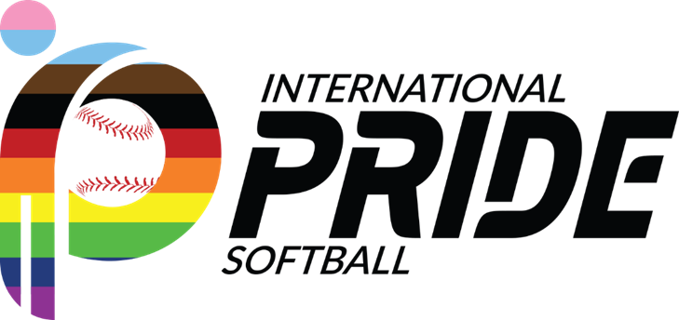
How to get Support from the City

Securing support from the city for an LGBTQ 501(c)(3) softball league involves building relationships, demonstrating the league's positive impact on the community, and showcasing the benefits the league brings to the city. Here are steps to help you get support:
1. Research City Programs and Initiatives:
- Identify Relevant Departments: Determine which city departments oversee sports, community engagement, LGBTQ+ affairs, or youth programs.
- Understand Grant Opportunities: Explore if there are specific grants, sponsorships, or community programs available that align with the league's mission.
2. Develop a Comprehensive Proposal:
- Outline the League's Impact: Create a proposal highlighting the league's positive influence on the LGBTQ+ community, including social inclusion, health benefits, and community engagement.
- Present Benefits to the City: Emphasize how the league contributes to the city's diversity, promotes inclusivity, and enhances community cohesion.
3. Build Relationships:
- Attend City Council Meetings: Engage with local government by attending council meetings, sharing the league's mission, and building rapport with council members.
- Meet with City Officials: Request meetings with relevant city officials or departments to discuss the league's objectives and how the city can support its initiatives.
4. Collaborate on Community Events:
- Host Community Events: Organize events, such as LGBTQ+ pride tournaments or community outreach programs, inviting city officials to participate or support.
- Partner with City Programs: Collaborate with city-run youth or sports programs, offering joint events or initiatives that align with mutual goals.
5. Showcase Positive Impact:
- Collect Testimonials and Data: Gather testimonials from league members, statistics on community engagement, and the league's influence on participants' well-being.
- Share Success Stories: Highlight stories of how the league positively impacts the lives of LGBTQ+ individuals within the city.
6. Promote City Benefits:
- Economic Impact: Demonstrate the league's contribution to the local economy through increased tourism, visitor spending, or local business support during tournaments.
- Positive Publicity: Showcase the city's support for diversity and inclusivity, which enhances its reputation as an LGBTQ+ friendly place.
7. Advocate and Engage:
- Advocate for Policy Support: Encourage city officials to advocate for LGBTQ+ rights and support initiatives that foster inclusivity in sports.
- Engage Community Support: Mobilize league members and supporters to advocate for city support through petitions, letters, or community outreach efforts.
8. Demonstrate Long-Term Sustainability:
- Showcase Long-Term Plans: Present the league's strategic plan, outlining future growth, development, and sustained community impact.
- Financial Stability: Highlight the league's financial stability, transparency in managing funds, and how city support can amplify its impact.
9. Follow-Up and Persistence:
- Stay in Communication: Keep city officials updated on league activities, successes, and opportunities for collaboration.
- Persistence and Patience: Building relationships and securing city support may take time; continue advocating and demonstrating the league's value.
By following these steps and engaging in ongoing dialogue with city officials, showcasing the positive impact on the LGBTQ+ community, and aligning the league's objectives with the city's interests, you can increase the likelihood of receiving support from the city for your 501(c)(3) LGBTQ+ softball league.

