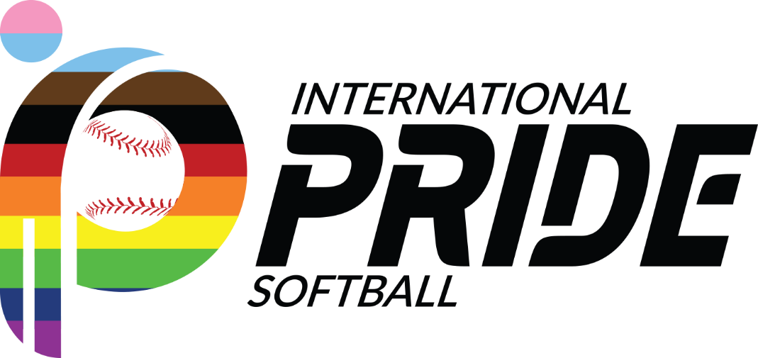

Guide- How to become an International Pride Softball Member

Thank you for showing interest in becoming An International Pride Softball member organization. Below we included a quick summary of IPS petitioning process.

Qualifications (confirmed by Membership Committee)
- The petitioning association has operated a league for two (2) consecutive calendar years preceding the meeting, with a minimum of four (4) teams registered each of those years.
- The petitioning association identifies itself as a sports organization in the LGBT community of its metropolitan area.
- The petitioning association’s representative attended the immediately preceding regular Meeting (Presence in two meetings).

Membership Committee will verify all requirements are met and provide recommendations to IPS Council on how to proceed with petition.

Meeting Attendance- Expectations
Per our qualifications, your organization will be required to attend two subsequent IPS meetings.
- First Meeting- Goal is to show the Member Organizations your interest in becoming part of IPS. Your representative will be able to listen to discussion, network with member cities, and participate in Committee breakouts.
- Second Meeting- During this meeting, your organization will be petitioning membership. You will be asked to present a summary of your organization, answer questions from Members. Upon proper petition and qualification, membership in IPS shall be granted or denied by the Council.

What do I need for my petition presentation?
Petitions for membership should be completed in the form and manner provided by the Membership Committee. Currently we ask petitioning organizations to prepare a 5-minute presentation, followed by Q&A session with Council.

What to share with the IPS Council

- Association tenure, size, composition | - Your website (or when one will be created)
- Leagues- Summer, fall | - Social Media outreach strategy
- Recruitment | - Local league board
- Team/players cost | - League’s Logo
- Other- Finance, Allies, etc.

What happens after the meetings?

If you are granted membership, you will be able to have voice and votes in all the Council items. You will be responsible to provide your first Membership fee during the Winter Meeting preceding your first Gay Softball World Series (GSWS) eligible participation ($350).

Membership committee will continue to partner with you during the first year as member. They will assign mentors and set meetings to support you and facilitate your participation in your 1st GSWS event.

How can I start the process?

Please contact the Membership chair at membershipchair@ipridesoftball.org to express interest or intention to petition for membership. Membership chair will partner with you to guide you through the membership process. Actions will include:
- Provide you with guidance to set your league for success.
- Coordinate Board introduction and logistics for meetings
- Answer questions around the petitioning process.

