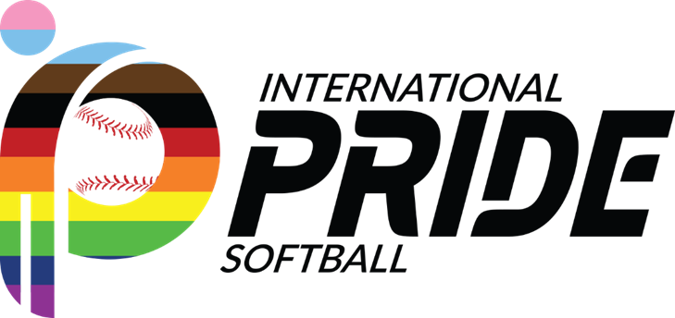

Dear new Association,
I am Jon Brenes, responsible for overseeing memberships at International Pride Softball. Enclosed is a document aimed at addressing most of the queries that typically arise when associations consider the process of seeking membership with us. Our primary objective within the Membership Department is to assist you in laying a solid foundation for your league's success, with the ultimate aspiration of your city becoming a part of IPS in the near future.
Prior to commencing the membership petition, we kindly request that we schedule an introductory call. This call will provide an opportunity for us to familiarize ourselves with your organization, understand your unique needs, and collaborate on strategies to surmount any obstacles that may arise during this journey.
We eagerly anticipate the chance to witness your city proudly represented at the Gay World Series!
Warm regards,
Jon Brenes Membership Chair Email: membershipchair@ipridesoftball.org

IPS Overview

IPS, the International Pride Softball, is a non-profit international sports organization comprised of men and women dedicated in providing opportunity and access to a safe environment where LGBTQIA+ community can participate in organized softball competitions. Currently, IPS has more than 17,000 players across 46 member cities in the United States (49) and Canada (3). Once a year, the best of these teams converge for head-to-head competition at the annual Gay Softball World Series, averaging over 200 teams and 3,000 athletes.
For over four decades, IPS has been a safe place for LGBT athletes. Member cities compete in seven divisions based on players’ skill level— A, B, C, D, E. Additionally, IPS has two categories: Legends C and Legends D, for individuals over 50 years old.
We are dedicated to the promotion of amateur sports competition, regardless of age, sexual orientation, or preference – with special emphasis on the participation of members of the LGBTQIA+ Community.
IPS sets the standards for fair softball play, supports local leagues with understanding and executing those standards and ensures accountability and compliance with the standards during IPS sponsored athletic competitions (IPS cup and GSWS).
For more information please visit: International Pride Softball – #iPrideSoftball

Membership Qualifications

For any membership petition to be considered by the Council, the requesting city organization must meet the following requirements:
- Association identifies as a sports organization in the LGBTQ+ community of its metropolitan area.
- Representatives from association attend two IPS meetings: the meeting where they are requesting membership and the preceding meeting.
- Petitioning association has operated for two years with a minimum of four teams registered in each of those years.
Based on COVID-19, we are taking in considerations the challenges for organized sports in order to help requesting cities apply for membership.

What softball rules do you abide to?

This organization, in all its official events, adopts and conforms to the USA Softball (ASA) Rules of Softball for Men’s Slow-Pitch, latest edition, with minimum modifications explicitly stated in the organization’s policy documents.

Does IPS control how we need to run our league?

No. Members of IPS and the organization of IPS are interdependent bodies, each mutually benefitting from one another and each with expectations to one another. Other than fulfilling the expectation of membership, is understood that IPS has no power to compel or direct the governance or operations of Member Associations.
Local league rules and team compositions are managed by Local Board. IPS only enforces the rules of play and qualifying requirements for their events (IPS cup and GSWS).

My league does not follow the current IPS divisions, and we have players with different skill levels playing together. Is that an issue?

No. In fact, some of our members cities operate in this same model. IPS will not tell you how to run your league. However, IPS establishes what are the criteria to qualify for the GSWS and IPS cup:
- Ten (10) players on the roster and may have a maximum of three non-LGBTQ+ players. Regular Season Roster team may not be comprised of more than twenty (20) players.
- To qualify as a team, players must play at least 50% of the games together, except in Legends Division where individuals are required to play a minimum of five games during a season.
- Teams can opt to add four additional players from any team in the league.

We understand sometimes is difficult to organize or commit full teams for our events. In the last years, we also added rules that facilitate participation for IPS Events.
An association can decide to send one all Association roster team per division; meaning, for your GSWS representation, you can form teams by selecting players from different teams within your league that meet the division and team requirements. In the case of E and Legends Divisions, team roster can always be open roster. This helps when players that want to travel together play in different teams.
If an association is sending only one team total to the GSWS, IPS allows the city to pick up to four players from other associations if the players selected have met the requirements in their respective cities. Legends Divisions can always pick players from other organizations if needed.

Do we need to rate and enter all my teams’ rosters in the IPS database? It seems a lot of work for our Board

Is recommended each member association shall rate every player, who has declared that association as the player’s qualifying city, using the Player’s Rating Guidelines. Rated players should be added to the IPS database, so they can be eligible to participate in the GSWS. It also facilitates their participation in local tournaments that enforce IPS ratings.
With that said, we understand the workload for the Board might be high at first. IPS and the membership committee can help by assigning a mentor to help you with the rating process. They can help explain how to rate player to coaches and how to enter players in database.
One recommendation is to train coaches to rate their teams and share their players ratings with local Board. We have made it easy for Local Board Members to load information in database, as now we have included a functionality to upload full teams using an Excel form. You will be able to transfer your player from previous seasons with ease, so the work every year will become easier, and you will only need to load new players and teams.
Another suggestion is to prioritize traveling players and GSWS participants. If players and teams are not participating in the GSWS or IPS Cup, there is no real consequence to not adding all the players and teams in league, other than it might affect the total associations berths for GSWS.

How many teams can I send for GSWS?

Berths are assigned to cities based on the number of active teams in their regular seasons. We follow the following guidelines:

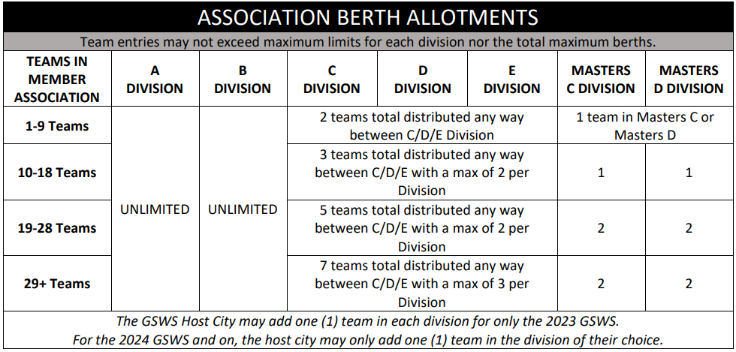

What if I am not able to send a team to the GSWS?

With all the flexibility we have created with the open roster, we feel that we are making easier for associations to participate in events. However, there might be unpredictable hardships that may not allow participation of a city. Even though our Governing Manual establishes that member cities could be subject to fines, IPS is very understanding and empathetic to the challenges some city might be facing and are open to discuss each case individually during the meeting following the GSWS. IPS will always have your best interest in mind.

How much is Membership to IPS? What about sending a team to GSWS?

Membership annual cost is $350 and is due prior the start of the Winter Meeting (January). No cost is required to request membership to IPS.

For GSWS, each participating team is required to pay $600 for tournament registration.

What is in it for me as a new organization?

As a new Member organization, your association can send teams from your city to IPS events. These events will provide a unique experience for your players, in which they will realize that through softball, they are part of something greater…a community of people that enjoy sports and competition, and an environment where people can strive and be their true self without fear of discrimination.

New member cities get the right to vote on items regarding rules and direction of our organization, and the voice to express themselves. Your local organization will be part of the discussion and decision making for the organization, influence, and trigger change.

Finally, you will get to meet and network with other organizations. You will be able to discuss challenges and needs, and hopefully get innovative ideas you can implement locally. IPS is always looking for ways to help our member organizations, and we tackle many areas of concerns during our meetings (i.e., diversity, recruiting, retention, fundraising/sponsorships). IPS also helps identify local opportunities with National sponsors and financial opportunities at local level.

What happens next?

We appreciate the opportunity to continue to connect with you folks. For any additional questions or concern you can reach out to Jon Brenes at memberhipchair@ipridesoftball.org

If there is an interest in starting the membership request process, please let us know so we can partner with your organization.

Regardless of your local decision, we would like to keep our communications with you and hope we continue learning from you moving on.

